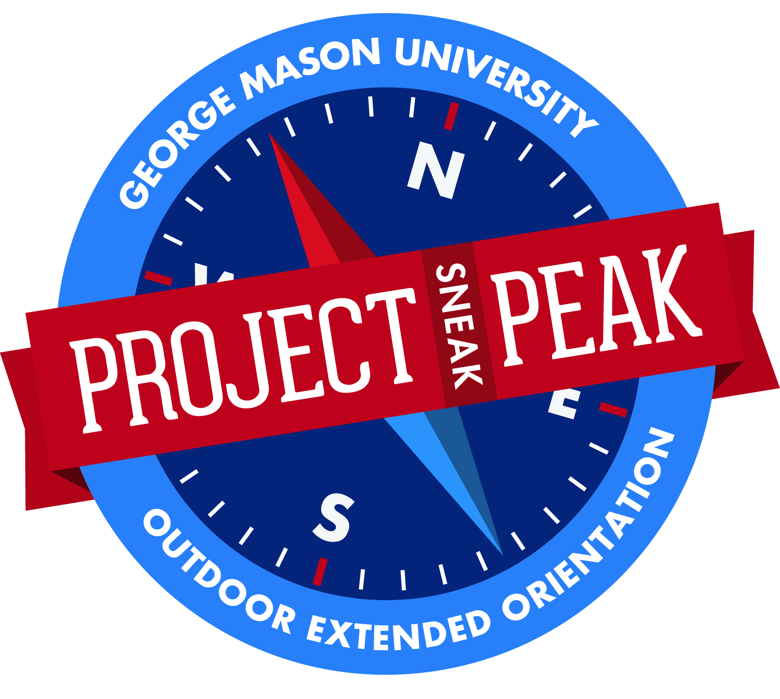
George Mason University’s
PROJECT SNEAK PEAK
Sponsored by the Transition Resource Center
For Registration Questions Please Call the Transition Resource Center:
703-993-9082 – Student Union Building I, Room 3600
http://transitions.gmu.edu/projectpeak/sneakpeak

Student’s Name____________________________________ Date of birth ___________

Student ID Number______________________________________ Gender____________

Address__________________________________________________________________________________________

Phone___________________________ Students E-mail___________________________________________________

Do you have any special dietary needs?_________________________________________________________________
How did you hear about Project Sneak Peak?_____________________________________________________________
Will you need transportation to Dulles International Airport at the end of the trip? Yes_______ No_________
Please indicate the trip you would like to attend

Kayaking & Camping Trip from July 11th – July 12th - $100
Rock Climbing & Camping Trip from July 22nd – 23rd - $100

Urban Expedition & Service Trip from July 29th – July 30th - $45
Kayaking Trip (off-campus students ONLY) on August 20th - $100

Orientation: All Sneak Peak trips will begin after the conclusion of freshmen orientation. You do not need to be registered for that session of orientation to be eligible to attend. To register for orientation, please visit orientation.gmu.edu.

Registration: Full payment is due with registration form, and payment can be made by check or with a credit card. Registration fee includes food, transportation, activities, trained instructors, park permits, and group equipment. Students must provide sleeping bags, sleeping pads, and personal equipment. A detailed information packet outlining the program will be mailed to you shortly after receiving your registration.

Payment: Mail registration form and a check payable to George Mason University – Transition Resource center to:

George Mason University – Transition Resource Center
Attn: Project Peak Coordinator
4400 University Drive, MSN 2C4
Fairfax, VA 22030-4444
OR
Fax registration form with credit card information to (703) 993-9008

Cardholders Name (printed):________________________________________________
Type of card (VISA or MC):______________Credit card #: _____________________________________
Expiration Date: _______________ Signature of cardholder: _____________________________________

** Cancellation: Registration fees are non-refundable. If you are no longer able to attend, please contact the Transition Resource Center at 703-993-9082 to open up another spot for an interested student.

Additional information can be found on our website: http://transitions.gmu.edu/projectpeak/sneakpeak/

