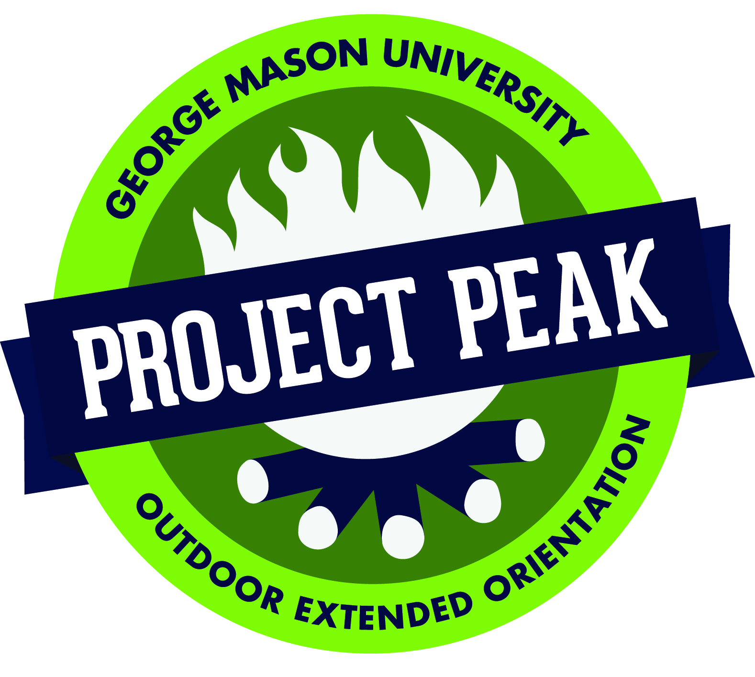
George Mason University’s Project Peak:
Outdoor Extended Orientation
Sponsored by the Center for Academic Advising, Retention & Transitions
(703)993-2470 – Student Union Building I, Room 3600 – http://transitions.gmu.edu/projectpeak

Student’s Name_______________________________Age (as of 8/20/2017)___________ Date of birth ___________

Student ID Number (G#)________________________ Gender______Preferred Pronouns (he/she/they):

Address____________________________City/State/ZIP_______________________________________________

Phone_________________________Student’s E-mail___________________________________________________

Do you have any special dietary needs?_______________________________________________________________
How did you hear about Project Peak? _______________________________________________________________
- Yes, I would like to purchase a 2017 Project Peak T-shirt for $10. T-shirt Size:

Once you are registered for Project Peak, you must also register and complete
UNIV 108 (0-1 credit) – a freshman transition course for Project Peak students.

Please register me for UNIV 108 on Monday/Wednesday 12:30pm-1:20pm.* | Please register me for the UNIV 108 Tuesday/Thursday 10:30am-11:20pm. * | Please register me for the UNIV 108 Tuesday/Thursdays 2:30pm-3:20pm.*  Please register me for the UNIV 108 Fridays 12:30pm-2:20pm.* | I will be taking UNIV 150 as a member of the Engineering or Arts UNIV 150 Living Learning Community.* | I am a member of one of the following Living Learning Communities: Business, Leadership & Community Engagement, Honors/Scholars, Mindful Living,  Environment & Sustainability, Outdoor Adventure**
* Note: Students will be registered for UNIV 108 or 150 upon acceptance into either Project Peak or a UNIV 150 LLC. Students must work around their UNIV 108 or UNIV 150 class when selecting courses at freshman orientation in the summer. Both courses are 0-1 credit. Full-time tuition is one price from 12-16 credits.
**Students in these LLCs will be required to take a course as part of their enrollment in the LLC. Please see the LLC coordinator for additional information or visit llc.gmu.edu.

Scholarships: Project Peak scholarships are available. For additional information, including deadlines, please see our website or call our office and request a form at (703)993-2470. You may also email trcdesk@gmu.edu.
Please check this box if you are applying for a scholarship. Scholarships decisions will be made on June 23, 2017. You must still submit payment with your registration but we will not process it until scholarship decisions are made.

Registration: Full payment of $375 is due with registration form, and payment can be made by check or with a credit card. Registration fee includes food, transportation, activities, trained instructors, park permits, and group equipment. Students must provide sleeping bags, sleeping pads, and personal equipment. Rental gear is available at a cost. The rental request form will be sent with your information packet. A detailed information packet outlining the program will be mailed to you shortly after receiving your registration. Please fill out all forms included in packet and return them to the Center for Academic Advising, Retention & Transitions by July 31, 2016. Cancellation: Registration fees are not refundable.

Early Move-In: Early move-in is available for Project Peak participants at no cost. Please see our website for more information.

Payment:
Mail $375($385 if purchasing a t-shirt) check payable to George Mason University –Project Peak
Attn: Project Peak Coordinator
4400 University Drive, MSN 2C4
Fairfax, VA 22030-4444
We cannot accept payment via email, phone or fax.

Cardholders Name (printed):________________________________________________
Type of card (VISA or MC):______________
Expiration Date: _______________
Credit card #: _____________________________________ CVV Code: (back of credit card)
Confirm Total Amount ($375 or $385 if purchasing t-shirt):
Signature of cardholder: _____________________________________

